**Assignment-1**

**BBS01T1002 Semiconductor Physics**

1. Write the formula for Fermi-Dirac distribution function and plot it for two different temperatures (T2 > T1).

ans)

**Fermi-Dirac distribution function**

images

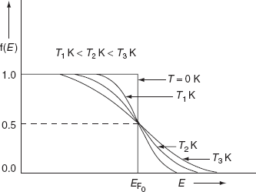

1. Write the expression of Eigen value and wave function for a free particle moving one dimensionally (1-D) in a potential well.

ans)

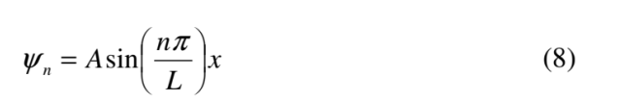

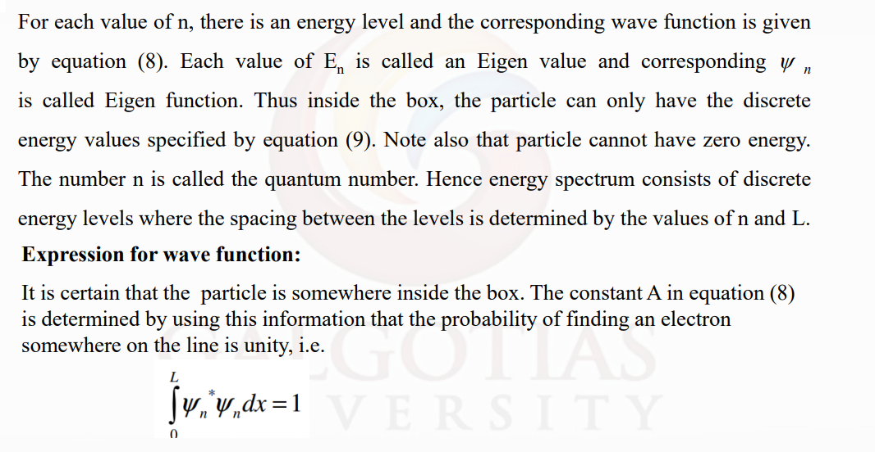

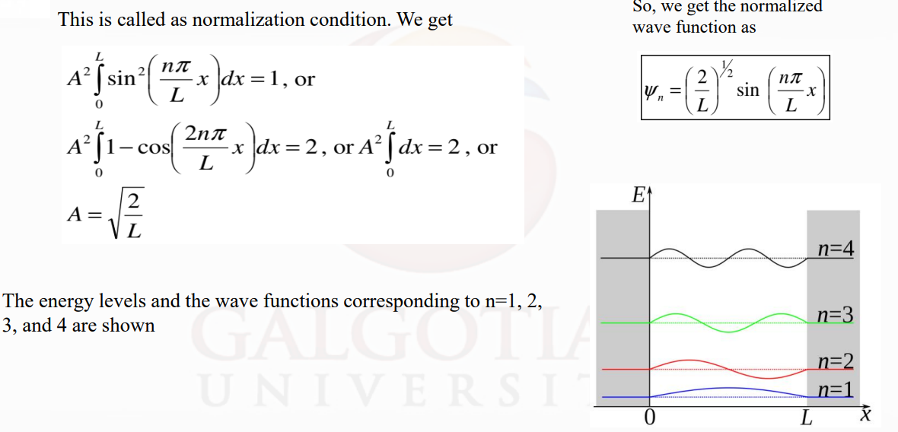

1. Explain the idea of wave function for a quantum particle. What are the basic characteristics of well-behaved wave function?

ans)

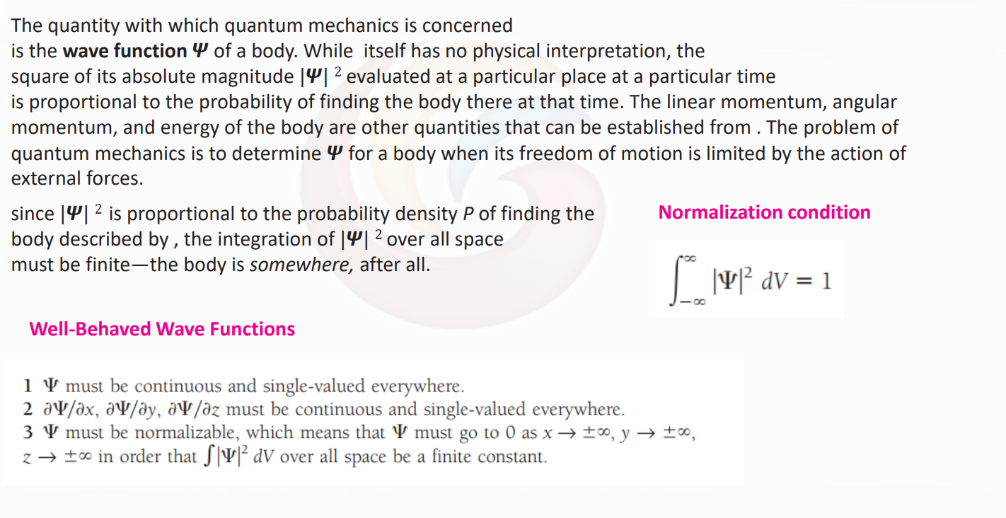

1. Define Fermi Energy. Write its expression.

ans)

**Fermi energy**is often defined as the highest occupied energy level of a material at absolute zero temperature. In other words, all electrons in a body occupy energy states at or below that body's Fermi energy at 0K.

The fermi energy is the difference in energy, mostly kinetic. In metals this means that it gives us the velecity of the electrons during conduction. So during the conduction process, only electrons that have an energy that is close to that of the fermi energy can be involved in the process.

This concept of Fermi energy is useful for describing and comparing the behaviour of different semiconductors. For example: an n-type semiconductor will have a Fermi energy close to the conduction band, whereas a p-type semiconductor will have a Fermi energy close to the valence band.

You can calculate the fermi energy state using:



N - number of possible quantum states  
V - volume  
m - mass of electron  
h - planc's constant

1. If the Fermi energy is 10eV, what is the mean energy of electron at 0K.

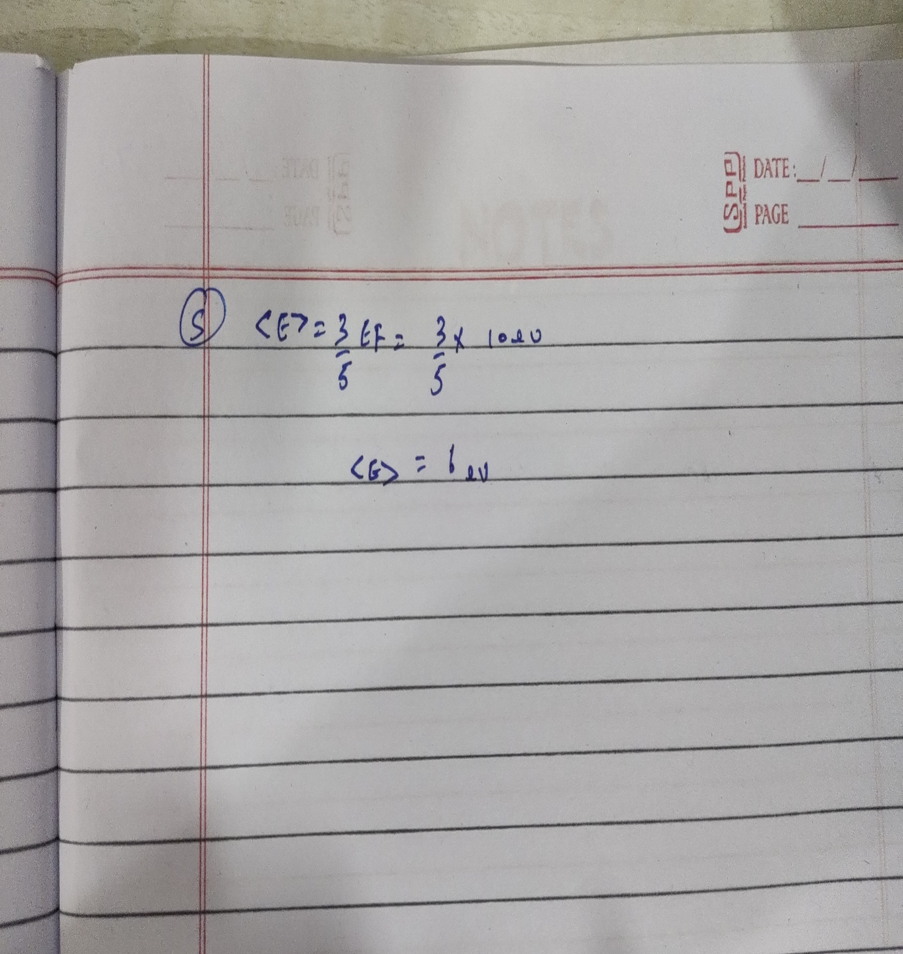

1. What would be the band structure if the barrier strength is extremely negligible? Justify your answer with diagram.

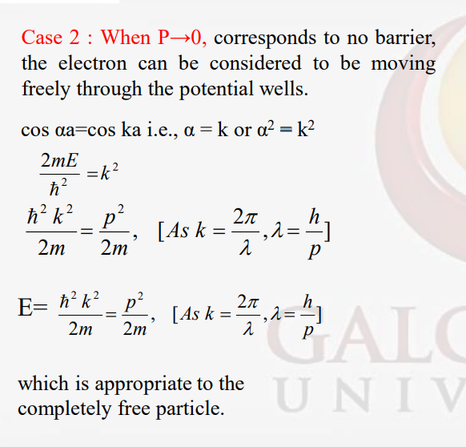

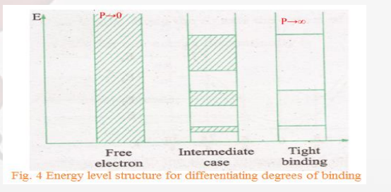

1. What would be the band structure if the barrier strength is extremely high? Justify your answer with diagram.

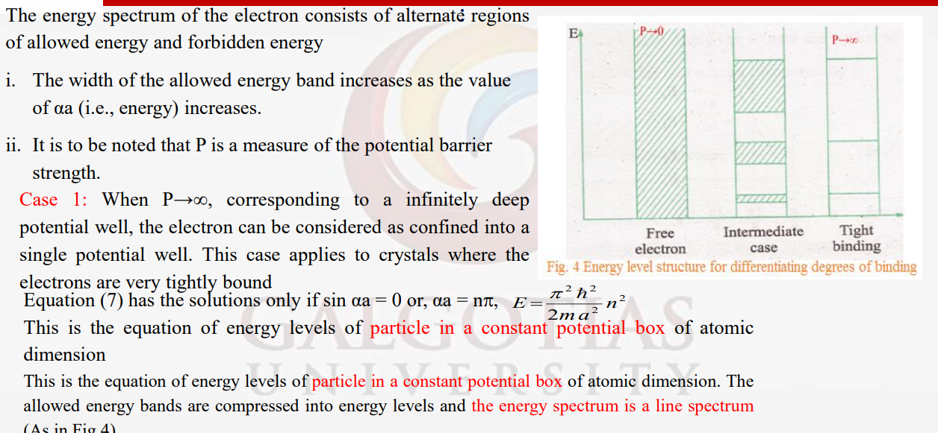

1. Based on band theory of solids, distinguish between conductors, semiconductors, and insulators.

ans)

A. Insulators

B. Semiconductor

C. Conductor.

1. Insulators • The forbidden energy gap (Eg ) is greater than 3eV • do not conduct electricity • number of electrons is just enough to completely fill a number of allowed energy bands. • Above these bands there exists a series of completely empty bands. • At ordinary temperatures electron can’t be thermally excited across this gap from the valence band to the conduction band. • As the bands are either completely filled or empty, no electric current flow.
2. • semiconductor exhibits an electrical conductivity intermediate between that of metal and insulators • the energy gap Eg is relatively small (of the order of 1eV). • an appreciable number of electrons can be thermally excited across the gap from the states near the top of the valence band to states the bottom of the conduction band. Semiconductor • As the temperature approaches absolute zero, the thermal excitation becomes vanishingly small and therefore all semiconductors behave as insulators at such temperatures.
3. • Upper most energy band is partially filled or if the uppermost filled band and the next unoccupied band overlap in energy, the crystal is known as conductors (metal). Conductor • the electron in the uppermost band find adjacent vacant states to move into, by absorbing energy from an applied electric field. These electrons thus behave as free electrons and conduct electric currents. •The band gap Eg of a typical insulator, such as diamond is about 6eV while that of semiconductors lies in the range of 2 eV to 2.5eV and in conductor it is zero • The electrical conductivity of a metal, at room temperature, is of order of 106mho/cm, that of semiconductor lies in the range 103mho/cm to 106mho/cm, and that of a good insulator is of order of 10-12 mho/cm.
4. Define the density of energy state in a solid. Find the expression for density of states.

ans)

Density of energy states is defined by the number of allowed energy states present in unit volume at a given energy. •Since even at highest energy, the difference between neighbouring energy levels is as small as 10-6 eV, in a macroscopically small energy interval dE there are still many discrete energy levels. So the concept of density of energy states is introduced. •The Fermi energy, EF is the energy of the highest filled level at absolute zero

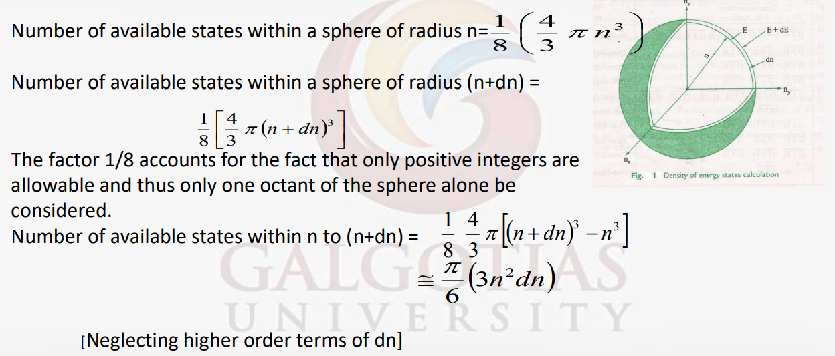

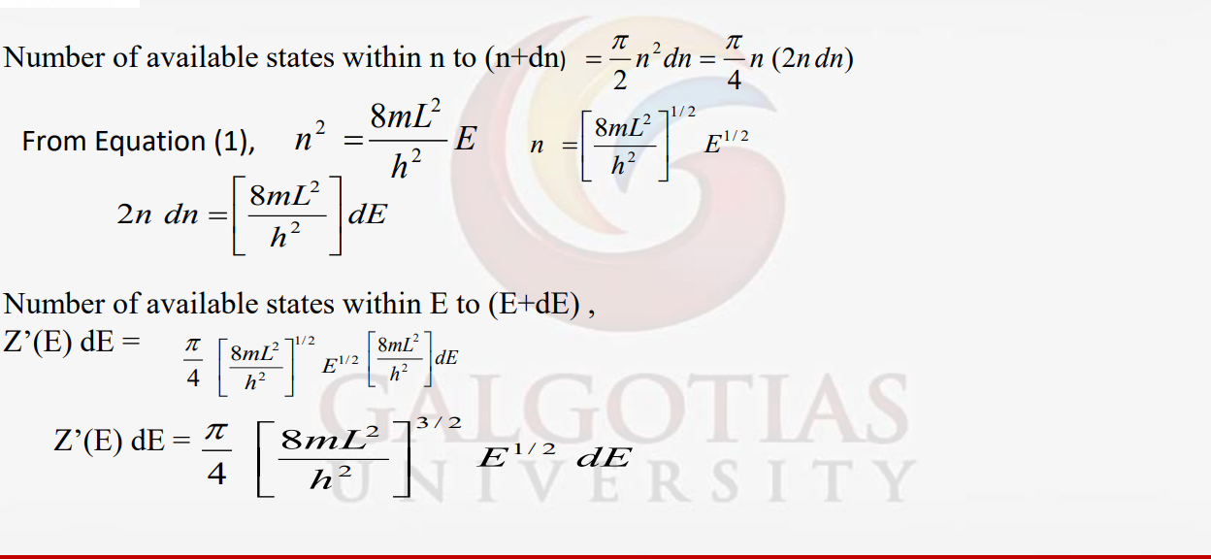

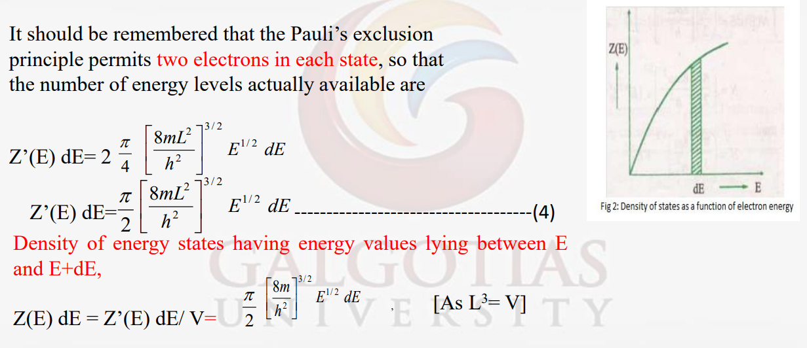

1. A particle is in motion along a line between x=0 and x=L with zero potential energy. At points for which x ≤ 0 and x ≥ L, the potential energy is infinite. Solving Schrodinger’s equation, obtain energy Eigen values and normalized wave function for he particle.

